## Background_CCDRKYR_Livestock analyzes:

**Objective**

This analysis aims to support the **adaptation analysis** of the Kyrgyz Climate Change and Development Report (CCDR) by providing accurate livestock herd and production data. It also assesses the **mitigation potential** for direct emission reductions in the livestock sector.

**Data Sources & Assumptions**

Reference data for 2022 is sourced from a study[1] conducted for a livestock analyzes used in the Kyrgyz Nationally Determined Contribution (NDC[2]), covering household cattle (which represent around 50% of the cattle herd) and sheep systems. For individual cattle systems (representing the other 50% of the cattle herd), we used data from a similar Uzbekistan system applied in the Uzbekistan CCDR[3], adjusting it to better reflect local production conditions. Adjustments include default values from GLEAM[4] for replacement rate and birth weight, as well as dietary modifications based on national expert input. Production and herd data were aligned with 2022 National Inventory Report (NIR) data[5] [6].

The **current growth scenario** assumes minimal production changes and herd growth based on FAOstat[7] trends from 2012 to 2022 for cows. Since sheep populations have stabilized in recent years, the 2017–2022 trend was used. Cattle farming is expected to shift towards individual farming systems, which will account for 60% of production by 2050, while household farms will represent 40%.

**Adaptation Analysis**

We compare the current growth scenario with two adaptation scenarios:

1. **Reform Scenario**
   * Based on Kyrgyz NDC livestock study, incorporating data based on an IFAD project in the region.
   * Targets 100% adoption of improved practices by 2050 (expanding beyond the original study, which covered 70% of household cattle farms and sheep farms by 2025).
   * Individual cattle farms adopt the same percentage of improvements as household farms, with adjustments to better fit their production systems (increased production assumptions and different feed changes).
2. **Resilience Scenario**
   * Builds on the reform scenario but assumes higher reductions in mortality, greater productivity gains, slight improvements in fertility, and better feed digestibility, to represent adaptation to climate change.
   * Better feed quality - including reduction of overgrazing - is reflected by increased maize silage use and decreased reliance on crop residues.
   * Furthermore, we increased the ratio of hay and alfalfa to promote drought-resistant fodder sources.

**Mitigation Analysis**

The mitigation analysis compares the current growth scenario with three mitigation scenario’s: improving efficiency, reducing herd size, and shifting dietary consumption towards broiler meat.

1. **Efficiency scenario:** Improve efficiency at the animal and herd levels, leading to higher milk production, and lower emission intensity.
   * Efficiency improvements are largely based on the reform scenario, aligning with government interventions.
   * However, we included the increasing use of biodigesters and composting in cattle systems, as this is clearly targeted in the NDC.
   * Furthermore, 25% of individual cattle farmers adopt methane inhibitors, reducing enteric methane emissions by 30%.
2. **Herd Size Adjustment** – Leveraging the higher productivity in the efficiency scenario, maintaining total protein production at the current growth scenario levels by reducing overall herd size.
3. **Dietary Shift** – Replacing 15% of ruminant-based protein consumption with poultry, which has a lower emission intensity per unit of protein.

**Results:**

**Table 1.1:** Estimated livestock emissions, emissions intensity, and protein production under various adoption and mitigation scenarios for Kyrgyz republic.

|  |  |  |  |  |  |  |  |  |  |  |  |
| --- | --- | --- | --- | --- | --- | --- | --- | --- | --- | --- | --- |
|  | | **Year** | | **Total_direct (mil tCO2-eq)** | | **EI (kgCO2-eq/kg protein)** | | **Protein_total (ton protein)** | | **Protein (g/cap/day)** | |
| REF | | 2022 | | 3.94 | | 64.05 | | 61546.50 | | 24.2 | |
| Current | | 2050 | | 6.53 | | 63.20 | | 103348.41 | | 29.4 | |
| Adoptation | | | | | | | | | | | |
| Reformed | | 2050 | | 7.03 | | 53.52 | | 131331.35 | | 37.3 | |
| Resilience | | 2050 | | 7.23 | | 52.23 | | 138490.22 | | 39.3 | |
| Mitigation | | | | | | | | | | | |
| Eff | | 2050 | | 6.93 | | 50.43 | | 137476.80 | | 39.1 | |
| Eff+Herd | | 2050 | | 5.24 | | 50.73 | | 103348.41 | | 29.4 | |
| Eff+Herd+dietary shift | | 2050 | | 4.50 | | 49.16 | | 91445.13 | | 26.0 | |

**Estimated livestock emissions, emissions intensity, and protein production under various adoption and mitigation scenarios for Kyrgyz republic** Livestock emissions contribute significantly to Kyrgyzstan's national greenhouse gas (GHG) emissions, accounting for ..% of total emissions and …% of total methane emissions. Addressing this sector is a key priority in Kyrgyzstan's Nationally Determined Contributions (NDC), which outline strategies such as replacing low-producing livestock, implementing advanced manure management practices, and rehabilitating degraded pastures. These measures aim to mitigate the significant rise in emissions from the livestock sector, which has increased by ..% from 1995, following the fall of the Soviet Union, to 2023.

Using the IPCC Tier 2 calculation methodology, which integrates data on herd parameters, feed practices, and manure management, this analysis examines the effects of adaptation measures and evaluates the potential of mitigation strategies on direct emissions from the livestock sector—specifically emissions resulting from enteric fermentation and manure management. The analysis concentrates on direct emissions from cattle and sheep, which together represent approximately % of total direct livestock emissions.

In the reference year 2022, these direct emissions were estimated at … million tons of CO₂-equivalent. With **current growth** in herd size and minimal advancements in herd management, feed efficiency, and manure handling, these emissions are projected to increase by ..% from 2022 to 2050, with protein production expected to reach … kg per ton per year.

When **reforms**, driven by government interventions such as enhanced health management, breeding programs, and feed optimization—particularly aimed at mitigating overgrazing—are implemented, productivity improves, resulting in an additional ..% increase in protein production by 2050. These measures enhance efficiency, reducing emissions intensity (EI) by ..%. However, due to the higher overall production, total emissions are still projected to rise by ..% in 2050.

With **climate-resilient measures**, resulting in productivity gains, slight fertility improvements, and better feed digestibility through greater resilience to climate shocks, EI is expected to decrease by ..% compared to the current growth scenario in 2050. However, similar to the reformed scenario, the increase in protein production by ..% still leads to a rise in total emissions by ..%.

To **mitigate emissions**, the government can invest in improved manure management (biodigesters, composting) and feed additives in more industrial systems, further reducing EI. However, significant reductions in emissions require herd size control. Keeping protein production at current growth levels while lowering EI reduces emissions by ..% in 2050. **Dietary shifts**, such as replacing 15% of ruminant beef with broiler meat, result in an additional ..% decrease, though total protein production declines due to fewer cattle and lower milk output. Combined, these measures result in a total emission reduction of .. tons of CO2 compared to current growth. This could potentially be supported by climate finance, facilitating the transition to more sustainable practices.

Despite these reductions, emissions remain higher than in the 2022 reference year. To meet government targets, further dietary shifts, possibly away from animal-source foods, may be needed. However, as livestock in the Kyrgyz Republic play a crucial role in livelihoods, herd reduction is challenging. A stepwise approach—one that integrates productivity gains, sustainable land use, and a gradual reduction of inefficient livestock, combined with dietary diversification—will be essential for achieving long-term sustainability.

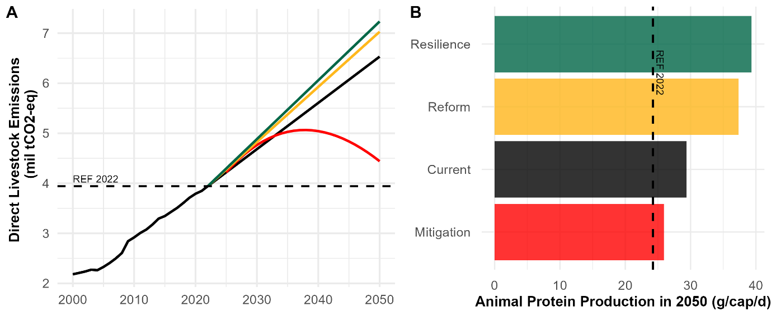

**Figure 1.1**.: Estimated direct livestock emissions and protein production per capita per day in Kyrgyz republic under various adaptation and mitigation scenarios (2000-2050)

Table: Overview of assumptions input Gleam-i



1. Abdurasulova, G., Wassie, S., Özkan, S., Dzhumabaeva, S., Mundy, O., Mottet, A., ... & Ibraimova, A. (2021). Analysis of Livestock and Pasture Subsectors for the NDC Revision in Kyrgyzstan. *IFAD: Bishkek, Kyrgyzstan*.
2. NDC: <https://unfccc.int/sites/default/files/NDC/2022-06/%D0%9E%D0%9D%D0%A3%D0%92%20ENG%20%D0%BE%D1%82%2008102021.pdf>
3. CCDR Uzbkistan: <https://www.worldbank.org/en/country/uzbekistan/publication/ccdr>
4. Gleam-i: <https://gleami.apps.fao.org/>
5. NIR Kyrgyzstan: <https://unfccc.int/documents/644907>
6. National database Kyrgyzstan: <https://stat.gov.kg/en/opendata/category/97/>
7. FAOstat database: <https://www.fao.org/faostat/en/>